**Smart RGB Bulb**

The smart RGB bulb is a bulb that can emit a wide variety of colours. All of that is controlled through an android app via Bluetooth. Apart from the Bluetooth control, the bulb can also be controlled via wifi.

Also the bulb is smart in a way that it can change its intensity according to the changes in the light intensity in the surroundings.

**Block diagram for control via Bluetooth:**

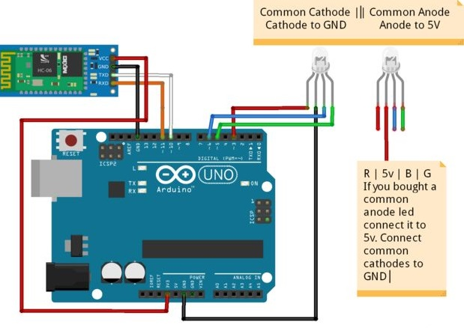

**Block diagram for control via wifi:**

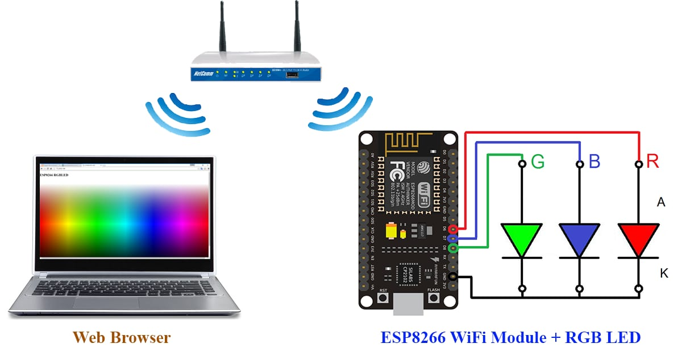

**Context based:**

1) Controlling visual theme and effects using Android app.

2) Menu based selection of visual themes and lighting

3) Detecting presence of people and lighting the nearby lamps.

4) Energy saving through optimization of lighting

**Applications:**

Home, exhibitions, discos, fairs, international events like launch of products/award ceremonies, auditoriums and theatres, marriage ceremony, birthday parties, etc

Controlling mechanism through Bluetooth module:

1. Controller : Arduino
2. Communication Device : Bluetooth module SE04
3. Display and lighting using light emitting diodes
4. Software used : Android studio, Blink | Arduino 1.8.5